|  |  |  |
| --- | --- | --- |
| **Course : (WEB322) -Web Programming Tools and Frameworks** | **Assignment 3-5 of 5** | **Contribution:10%(each)- 30% of course** |
| **Instructor : Kadeem Best** | **Date Given:** | **Date Due** |

**Notes for the Student:** This Project corresponds to Assignment 3, 4, 5 and is a continuation of the work you have already completed in Assignments 1 and 2.

**Background**: You will need to have access to an IDE or text editor and have a thorough understanding of Node.js, Express,Git ,(GitHub or Bitbucket) ,Heroku, MongoDB and Mongoose.

**Assignment Regulations**

* This project must be done individually.
* **An in-person demonstration of this project is required. Failure to demonstrate your project would result in 0 marks.**
* You must create a private Git repository and add me as a collaborator.
* **Because this project is due on the last day of class, no late submissions will be accepted.**
* Please review Seneca’s policies on Academic Integrity, specifically:

*“Each student should be aware of the College's policy regarding Cheating and Plagiarism. Seneca's Academic Policy will be strictly enforced.To support academic honesty at Seneca College, all work submitted by students may be reviewed for authenticity and originality, utilizing software tools and third party services. Please visit the Academic Honesty site on http://library.senecacollege.ca for further information regarding cheating and plagiarism policies and procedures..”* ***Thus, ensure that your code or any part of it is not duplicated by another student(s). This will result in a percentage of zero (0%) assigned to all parties involved.***

**Technical Requirements**

* All back-end functionality MUST be done using Node JS and Express.
* Your views MUST be created with Express-Handlebars
* You can use a CSS Framework such as Bootstrap, Bulma or Materialize CSS to make your website responsive and aesthetically pleasing. Or, you can also continue to use Vanilla CSS to build your website. The option is yours.
* You can use any animation library (JavaScript or CSS) that you want.This is not mandatory, it is up to you.
* You are **NOT** allowed to use any Front-End JavaScript Frameworks, specifically, **No React, No Vue, No Angular.**
* You must use MongoDB as your database engine

# **Detailed App Specification**

This assignment is a continuation of Assignment 1 and 2, thus all the requirements for this assignment is to be made “on top” of your Assignment 1 and 2.

# Assignment 3 (10%)

## **Application Architecture**

1. Your application **MUST** be structured **FULLY** according to the MVC Design pattern. Thus, your views, models and controllers must be separated as per the design pattern requirements.
2. **All** sensitive credential information **must** be stored in **environment variables**. Examples include: your sendgrid access token, MongoDB connection string, etc. Implement environment variables locally using the [dotenv](https://www.npmjs.com/package/dotenv) 3rd party package.

## 

## **User Registration Module**

You are required to implement database functionality for your registration page that was previously implemented in Assignment 1 and 2 . Thus, when a user fills out the registration form and then hits the submit button, provided that all the validation criteria were not violated, your website must then create a user account in your database.

**Once the user account is created, your web application must then redirect the user to a dashboard page.**

Regarding your database functionality, the following rules must be followed :

1. Setup and configure a MongoDB cloud service using MongDB Atlas <https://www.mongodb.com/cloud/atlas>.
2. Connect your web application to your mongoDB database using an ODM called **Mongoose.**
3. Name your database and collections appropriately.
4. Ensure that the email field in your registration form **is** **unique**, thus your application must prohibit different users from having the same email in the database.
5. Passwords **must not** be stored in plain text in the database, thus your application must store passwords in an encrypted format. You can use a 3rd party package called [**bcryptjs**](https://www.npmjs.com/package/bcryptjs) to do the aforementioned.

## **Authentication Module**

You are required to implement a fully functional authentication module with the following features:

* Your application must allow an Data Entry Clerk and customers who want to purchase meal packages, to **log-in via the login form created in Assignment 1 and 2.**
* Upon a successful authentication(entering an email and password pair that exists in the database) **a session must be created to maintain the user state until they have logged out of the application.**
* **To implement sessions** in an Express app you can use <https://github.com/expressjs/session>
* Upon an unsuccessful authentication, the application **must** display an appropriate message (Example: **Sorry, you entered the wrong email and/or password**)
* Also after successfully authenticating,the application must determine if the person logging in is a data entry clerk or a regular user and will be redirected to their respective dashboard.
* A customer will be directed to a user dashboard and a data entry clerk will be directed to a data entry clerk dashboard.
* Both dashboards, must show the user’s name(first name and lastname) and a logout link
* The logout link must destroy the session created when the user initially authenticated.
* Specific routes can only be accessed when users are logged-in, thus those routes must be protected.

# Assignment 4 (10%)

# 

## **Data Entry Clerk Module**

You are required to implement a Data Entry Clerk module that allow an data entry clerk to do the following :

1. **Create Meal Packages:** The Data Entry Clerk must be able to add new meal packages to the database. See the following data that must be added when a product is created:
   1. Meal Package name,
   2. Meal Package price,
   3. Meal Package description or details,
   4. Meal Package food category
   5. The number of meals inside the package
   6. Set Meal package as a top package to be shown on the home page(or not).
   7. Upload a photo of the meal package(to keep the project simple, only upload one image per meal package).
2. Ensure that all created meal packages that were entered into the database are populated on the front-end of the web application, specifically on the meal package listing page that was created in Assignment 1 and 2. Additionally, only meal packages that were set as “Top Meal Packages” should be populated in the “Top Meal Package” section of the home page. **Please note, a visitor to the web application does not need to be logged in to view the meal packages that were created by the data entry clerk.**
3. Ensure that a user can only upload an image, i.e jpgs,gifs,pngs, for the meal package photo.
4. View a list of all created meal packages.
5. Edit and change meal package details for a selected meal package. Example : price, title etc

Please note, a Data Entry Clerk must be logged-in to the web application to be able to do the aforementioned (create meal packages, view all created meal packages, edit and change meal package details). To facilitate the logging in of the Data Entry clerk, create a regular user in the Front-End and then long into your MongoDB Atlas account and manually change a field in the document to make allow the application to able to make the distinction between customer vs data entry clerk - **I will further expound on this in class.**

# Assignment 5 (10%)

## 

## **Meal Package Description Page**

Only logged in users should be able to “purchase” meal packages by adding selected meal packages to their shopping cart.

From the meal package listing page, when a user clicks on a particular meal package, they should be navigated to the **Meal Package Description page** of the clicked meal package and from that page they can add the meal package to their shopping cart.

Sample of a Product Description Page Example :

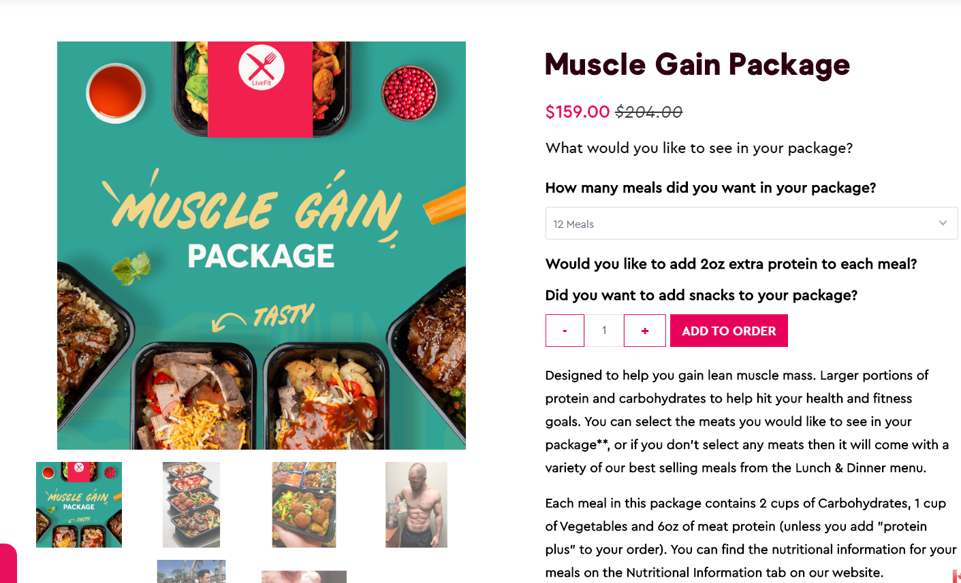

The Meal Package Description page of any meal package should list the following:

1. Meal Package Image
2. Meal Package title
3. Meal Package description
4. Meal Package price
5. No of meals within the package
6. Add to order

When the user clicks the “**Add to order**” button, the given package will be added to the user's shopping Cart.

## **Shopping Cart Module**

The customer’s dashboard should have a link to the logged-in user shopping cart . This page must display all the meal packages that were added to the shopping cart and how much of each package was added for the given user. Also, the page should have a “Place your order” button.

See Example

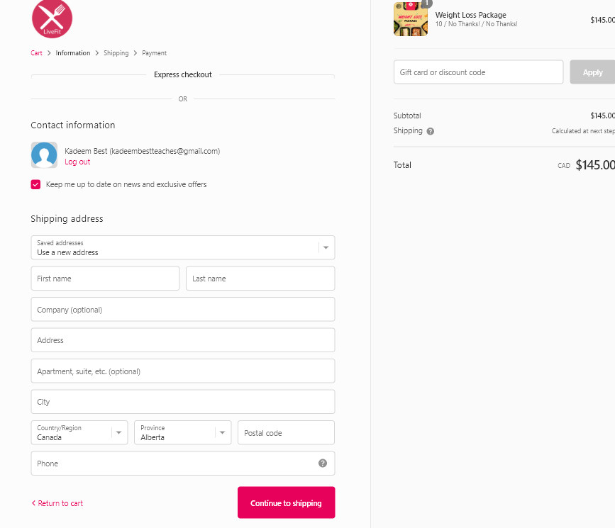

When the “**Place your order**” button is pressed, your web application should “clean” your shopping cart, send an email to the logged in user’s email, indicating all the packages purchased and the quantity amount for each meal package purchased as well as the customer’s order total.

## Assignment 3 Rubric

|  |  |  |  |
| --- | --- | --- | --- |
| **Criteria** | **Not Implemented**  **0** | **Partially**  **Implemented**  **1** | **Fully**  **Implemented**  **2** |
| **User Registration**   * MongoDB cloud service is setup Database and collection have appropriate names * User’s data is inserted into the database when the user fills out the form and hits the submit button. * User is redirected to a dashboard page when form is submitted * Email Is unique * Password is stored in encrypted format (12) |  |  |  |
| **Authentication**   * **A Session is created to maintain the user state until the user logs out of the application.** * Upon an unsuccessful authentication, the application displays an appropriate error message * The application directs a data clerk to their dashboard and a regular user to his or her dashboard. * Both dashboards, show the user’s name(first name and lastname) and a logout link * The logout link destroys the session. * Routes that can only be accessed when users are logged-in, must be protected. |  |  |  |

**Total : 24 MARKS**

## Assignment 4 Rubric

|  |  |  |  |
| --- | --- | --- | --- |
| **Criteria** | **Not Implemented**  **0** | **Partially**  **Implemented**  **1** | **Fully**  **Implemented**  **2** |
| **Data Clerk Module**   * A data Clerk account is manually created in the database. * An data Clerk can create meal packages with all the necessary data * An data can upload a photo for a meal package * Only a Images can be uploaded as a photo. * All meal packages created are populated on the Front-End of the website, specifically the meal package listing Page * Meal packages that are set as top meal packages are rendered in the appropriate section on the home page. * The data Clerk can view a list of all created meal packages. * Data Clerk can edit product details |  |  |  |

**Total : 16 MARKS**

## Assignment 5 Rubric

|  |  |  |  |
| --- | --- | --- | --- |
| **Criteria** | **Not Implemented**  **0** | **Partially**  **Implemented**  **3** | **Fully**  **Implemented**  **5** |
| **Booking Module**   * Only logged in users can add meal packages to their shopping cart. * User’s must be able to view all their meal packages in their shopping cart and the shopping cart must list all meal packages added, the quantity amount of each product and their total amount. * When the user clicks the “Place Order” button, the application must “clear” the shopping cart and send email with the entire order information |  |  |  |

|  |  |  |  |
| --- | --- | --- | --- |
| Look and Feel   * Overall site looks polished on all devices. | **0** | **5** | **10** |

**Total : 25 MARKS**

**THE END**